Praktikum 10
Android MySQL Create dan Multi Read

1. Sebelum memulai dengan proyek Android, nyalakan XAMPP yang terpasang di komputer masing-masing. Lalu cek apakah localhost bisa diakses atau tidak.
2. Jika berhasil mengakses, gunakan PHPMyAdmin untuk membuat database “android” dan tabel “databarang” baru.
3. Kolom-kolom di tabel “users”:
+------------+--------------+------+-----+---------+----------------+
| Field | Type | Null | Key | Default | Extra |
+------------+--------------+------+-----+---------+----------------+
| id | int(11) | NO | PRI | NULL | auto_increment |
| kodebarang | varchar(100) | NO | UNI | NULL | |
| namabarang | varchar(100) | NO | | NULL | |
| kuantitas | int(11) | NO | | NULL | |
+------------+--------------+------+-----+---------+----------------+

4. Hasil dari Database dan Tabel:
DB android
+--------------------+
| Database |
+--------------------+
| android |
| information_schema |
| mysql |
| performance_schema |
+--------------------+
Tabel databarang
+-------------------+
| Tables_in_android |
+-------------------+
| users |
+-------------------+

5. Isilah dengan data Dummy untuk menguji Aplikasi Android nanti, contoh:
+----+---------+----------+----------+
| id | nama | username | password |
+----+---------+----------+----------+
| 1 | Maulana | maulana | maulana |
+----+---------+----------+----------+

6. Berikutnya adalah membuat file PHP di htdocs (Pastikan file bisa diakses nanti!)
connect.php
<?php
$HOST = 'localhost';
$USER = 'root';
$PASS = 'root';
$DB = 'android';
$CON = mysqli_connect($HOST,$USER,$PASS,$DB) or die(mysqli_error($CON));
?>
read.php
<?php
require_once('connect.php');

$id = $_GET['id'];
// $id = '1'

$result = array();
$query = mysqli_query($CON,"SELECT * FROM users WHERE id=".$id.";") or die(mysqli_error($CON));
while($row = mysqli_fetch_assoc($query)){
$result[] = $row;
}
echo json_encode(array('result'=>$result));
?>

7. Tes koneksi ke PHP dengan menggunakan Web Browser, gunakan http://localhost/read.php?id=1 (tergantung dari letak file!!!). Jika benar akan muncul gambar berikut:

8. Lalu buatlah proyek baru dengan Android Studio
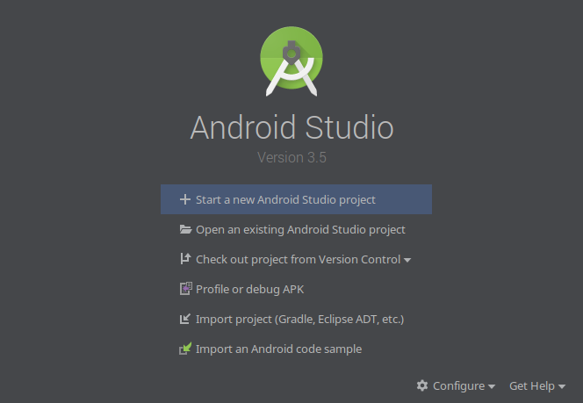

9. Pilih Empty Activity untuk memulai aplikasi baru
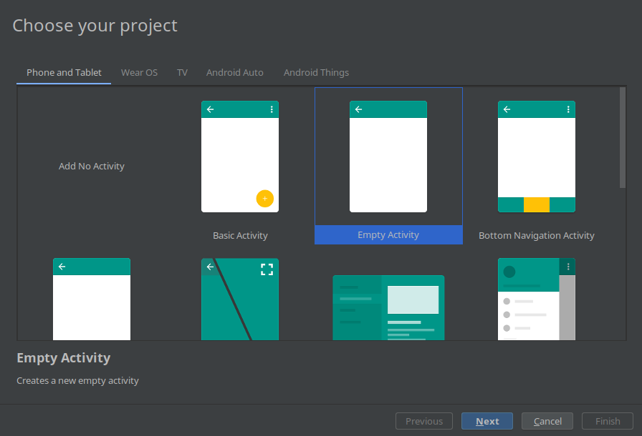

10. Bukalah file build.gradle (Module: app) lalu tambahkan tulisan tebal putih berikut:
dependencies {
implementation fileTree(dir: 'libs', include: ['*.jar'])
implementation"org.jetbrains.kotlin:kotlin-stdlib-jdk7:$kotlin_version"
implementation 'androidx.appcompat:appcompat:1.0.2'
implementation 'androidx.core:core-ktx:1.0.2'
implementation 'androidx.constraintlayout:constraintlayout:1.1.3'
testImplementation 'junit:junit:4.12'
androidTestImplementation 'androidx.test:runner:1.1.1'
androidTestImplementation 'androidx.test.espresso:espresso-core:3.1.1'
implementation 'com.amitshekhar.android:jackson-android-networking:1.0.2'
}

11. Sync Project, lalu tambahkan kode berikut ke AndroidManifest.xml
<?xml version="1.0" encoding="utf-8"?>
<manifest xmlns:android="http://schemas.android.com/apk/res/android"
package="com.example.sqlquery">
<uses-permission android:name="android.permission.INTERNET"/>

12. Kemudian buatlah Layout sebagai berikut:
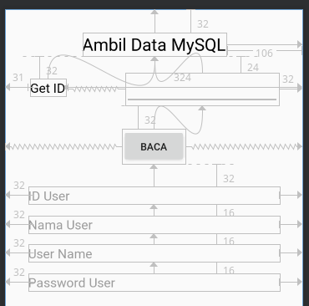
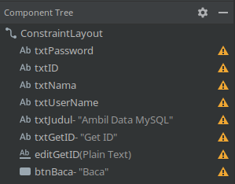

13. Kemudian edit MainActivity.kt
package com.example.sqlquery
import android.app.ProgressDialog
import androidx.appcompat.app.AppCompatActivity
import android.os.Bundle
import android.util.Log
import android.widget.Button
import android.widget.EditText
import android.widget.TextView
import android.widget.Toast
import com.androidnetworking.AndroidNetworking
import com.androidnetworking.common.Priority
import com.androidnetworking.error.ANError
import com.androidnetworking.interfaces.JSONObjectRequestListener
import org.json.JSONObject
import okhttp3.OkHttpClient
import androidx.core.app.ComponentActivity
import androidx.core.app.ComponentActivity.ExtraData
import androidx.core.content.ContextCompat.getSystemService
import android.icu.lang.UCharacter.GraphemeClusterBreak.T
class MainActivity : AppCompatActivity() {
override fun onCreate(savedInstanceState: Bundle?) {
super.onCreate(savedInstanceState)
setContentView(R.layout.activity_main)
// Inisialisasi View
val btnGetID = findViewById<Button>(R.id.btnBaca)
var editGetID = findViewById<EditText>(R.id.editGetID)
var editID = findViewById<TextView>(R.id.txtID)
var editNama = findViewById<TextView>(R.id.txtNama)
var editUserName = findViewById<TextView>(R.id.txtUserName)
var editPassword = findViewById<TextView>(R.id.txtPassword)
AndroidNetworking.initialize(applicationContext)
// Definisi Alamat Web Service
val SERVER = "http://192.168.xxx.xxx/android/"
// Aksi BUtton
btnGetID.setOnClickListener {
editID.text = "memuat..."
editNama.text = "memuat..."
editUserName.text = "memuat..."
editPassword.text = "memuat..."
// Panggil PHP read.php
var READ = SERVER+"read.php?id="+editGetID.getText().toString()
// Gunakan URL READ untuk Ambil JSON
AndroidNetworking.get(READ)
.setPriority(Priority.MEDIUM)
.build()
.getAsJSONObject(object : JSONObjectRequestListener
{
// Jika Berhasil
override fun onResponse(response: JSONObject?) {
val jsonArray = response?.optJSONArray("result")
// Jika Data Kosong
if(jsonArray?.length() == 0){
editID.text = " "
editNama.text = " "
editUserName.text = " "
editPassword.text = " "
Toast.makeText(applicationContext,"Data Kosong",Toast.LENGTH_SHORT).show()
}
// Tarik Data dari JSON
for(i in 0 until jsonArray?.length()!!){
val jsonObject = jsonArray?.optJSONObject(i)
editID.text = "ID : " + jsonObject.getString("id")
editNama.text = "Nama : " + jsonObject.getString("nama")
editUserName.text = "UserName : " + jsonObject.getString("username")
editPassword.text = "Password : " + jsonObject.getString("password")
}
}
// Jika Terjadi Error
override fun onError(anError: ANError?) {
editID.text = " "
editNama.text = " "
editUserName.text = " "
editPassword.text = " "
Log.d("ONERROR",anError?.errorDetail?.toString())
Log.d("Info:",READ)
Toast.makeText(applicationContext,"Connection Failure",Toast.LENGTH_SHORT).show()
}
})
}
}
}

14. Kompile Kode dan Jalankan

